**Lab 10**

**Lab 10 - Code**

**people.py**

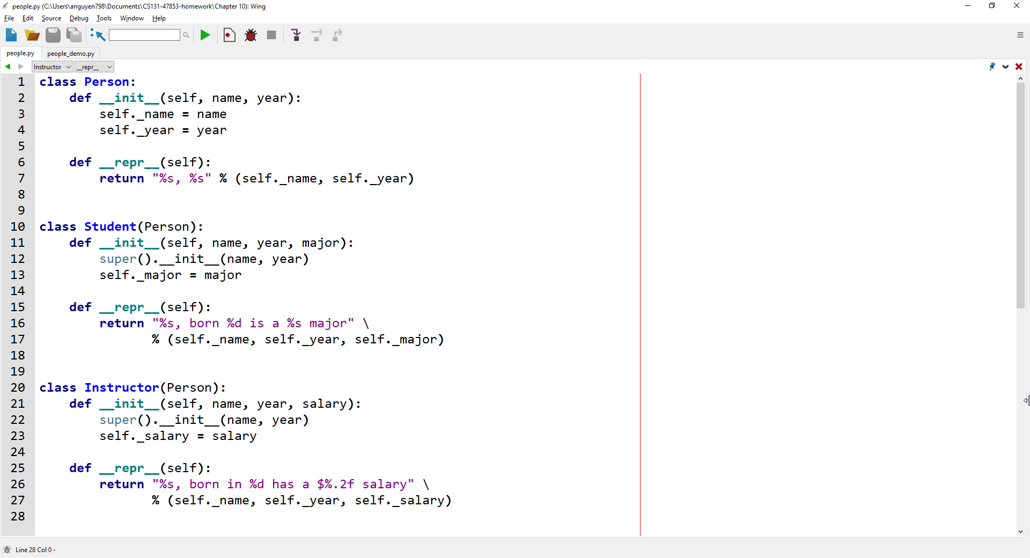

**people_demo.py**

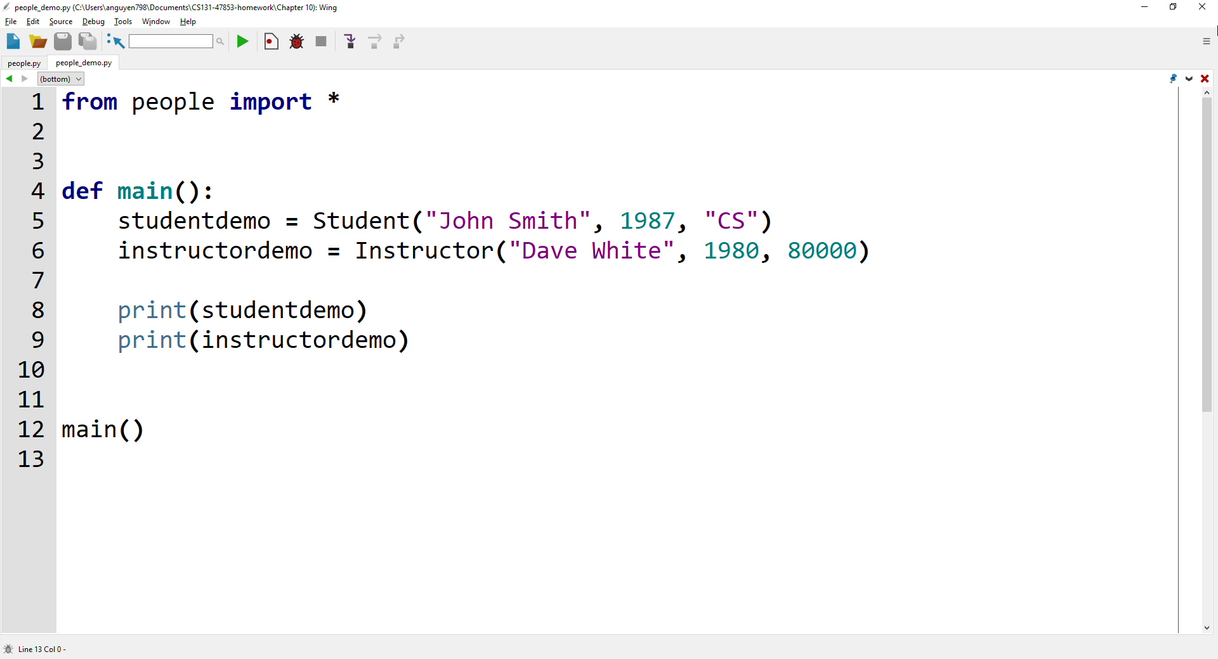

**Lab 10 - Output**

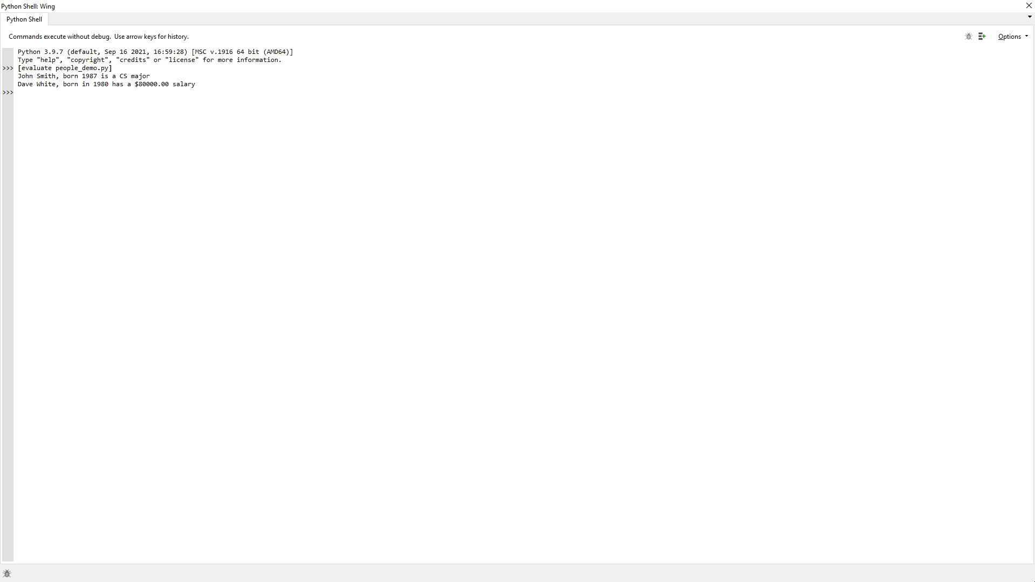

**Lab 10 – Written Code**

**people.py**

class Person:

    def __init__(self, name, year):

        self._name = name

        self._year = year

    def __repr__(self):

        return "%s, %s" % (self._name, self._year)

class Student(Person):

    def __init__(self, name, year, major):

        super().__init__(name, year)

        self._major = major

    def __repr__(self):

        return "%s, born %d is a %s major" % (self._name, self._year, self._major)

class Instructor(Person):

    def __init__(self, name, year, salary):

        super().__init__(name, year)

        self._salary = salary

    def __repr__(self):

        return "%s, born in %d has a $%.2f salary" % (self._name, self._year, self._salary)

**people_demo.py**

from people import *

def main():

    studentdemo = Student("John Smith", 1987, "CS")

    instructordemo = Instructor("Dave White", 1980, 80000)

    print(studentdemo)

    print(instructordemo)

main()